**Section 2–6A: Families of Functions (Translation)**

**Introductions:**

Different non-vertical lines have different slopes, or *y*-intercepts or both. They are graphs of different linear functions. For two such lines, you can think of one as a ***transformation*** of the other. There are sets of functions, called ***families***, in which each function is a transformation of a special function called the ***parent***.

The linear functions form a family of functions. Each linear function is a transformation of the function $y=x$. The function $y=x$ is the ***parent*** linear function. A **parent function** is the simplest form in a set of functions that form a family. Each function in the family is a **transformation** of the parent function.

One type of transformation is a **translation**. A translation shifts the graph of the parent function horizontally, vertically, or both without changing shape or orientation.

For a positive constant $k$ and a parent function $f(x)$, $f(x)±k$ is a **vertical translation**.

For a positive constant $h$ and a parent function $f(x)$, $f(x±h)$ is a **horizontal transition**.

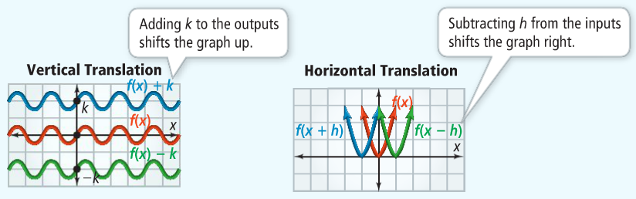

**Recall:**

**Linear Functions** – all graphs of linear functions are lines that are transformation of the ***parent linear function $y=x$*** or $f\left(x\right)=x$.

**Looking Ahead: (Chapter 4 Section 1)**

**Quadratic Functions** – all graphs of quadratic functions, called parabolas, are a transformation of the ***parent quadratic function $y=x^{2}$*** or $f\left(x\right)=x^{2}$.

**Example 1: Vertical Translation**

Graph each linear function. Compare it to the graph of the parent function, $y=x$.

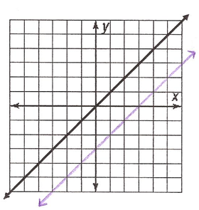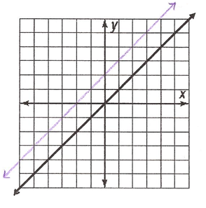**A. $y=x+2$**  **B. $y=x-3$**

**Example 2: Vertical Translation**

Complete the table and graph all three functions on the same coordinate plane.

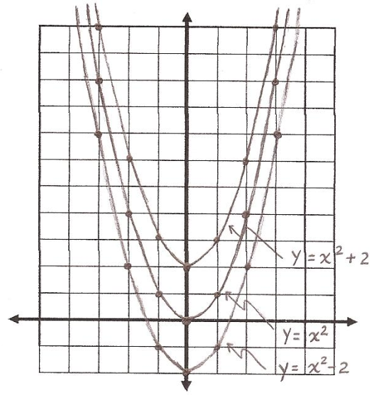

|  |  |  |  |
| --- | --- | --- | --- |
| $$x$$ | $$y=x^{2}$$ | $$y=x^{2}+2$$ | $$y=x^{2}-2$$ |
| $$-3$$ | $$9$$ | $$11$$ | $$7$$ |
| $$-2$$ | $$4$$ | $$6$$ | $$2$$ |
| $$-1$$ | $$1$$ | $$3$$ | $$-1$$ |
| $$0$$ | $$0$$ | $$2$$ | $$-2$$ |
| $$1$$ | $$1$$ | $$3$$ | $$-1$$ |
| $$2$$ | $$4$$ | $$6$$ | $$2$$ |
| $$3$$ | $$9$$ | $$11$$ | $$7$$ |

**Example 3: Horizontal Translation**

Complete the table and graph all three functions on the same coordinate plane.

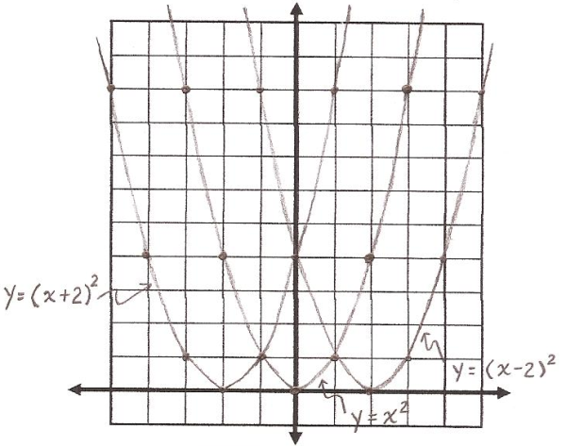

|  |  |  |  |
| --- | --- | --- | --- |
| $$x$$ | $$y=x^{2}$$ | $$y={(x+2)}^{2}$$ | $$y={(x-2)}^{2}$$ |
| $$-3$$ | $$9$$ | $$1$$ | $$25$$ |
| $$-2$$ | $$4$$ | $$0$$ | $$16$$ |
| $$-1$$ | $$1$$ | $$1$$ | $$9$$ |
| $$0$$ | $$0$$ | $$4$$ | $$4$$ |
| $$1$$ | $$1$$ | $$9$$ | $$1$$ |
| $$2$$ | $$4$$ | $$16$$ | $$0$$ |
| $$3$$ | $$9$$ | $$25$$ | $$1$$ |